Reading eBooks on Mobile Devices
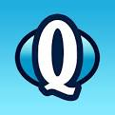
1) Open the Destiny Quest app
2) Enter URL: destiny.aisd.net
3) Select Little Elementary School
4) Log in with your Student ID number (lunch number) in both boxes.
5) Tap FollettShelf at the bottom left and this will open the eBooks shelf. When you find a book you want to read, tap on the cover to open it.

